**Sprint Goal:** Save state and community

**Spikes:**

* Spike 1: serialization
* Spike 2: connecting frontend to backend
* Spike 3: cookie creation and usage with https

**User story tasks:**

* **User Story 1 (post_to_canvas):** As a user, I want to click on a post and be directed to the canvas using the state and rules of the post so that I can explore others’ creations.
  + When a post is clicked, routes the user to the canvas page with the specified CA displayed (1 hour)
    - Store in local storage the current post id being viewed
  + Total: 1 hour
* **User story 2 (my_saved_posts):** As a creator/writer I want to be able to see all of my saved CAs in a page so that I can access my work
  + Able to click on a CA and restore it
  + Menu like community page (1 hour)
  + Total hour: 1 hour
* **User Story 3 (post_delete):** As a user, I want to be able to delete my own posts
  + Delete button on the community post for a user’s posts (less than hour)
  + API Route Delete (3 hours)
    - Frontend backend requester delete function
    - Database PostgreSQLConnect delete function
    - Upon click, removes post from shown list
  + Total: 3 hour
* **User Story 4 (export):** As a user, I want to be able to export an image of the current state of the CA to a png.
  + Have button on side to do this (3 hours)
  + Total: 3 hour
* **User Story 5 (compile_error):** As a user, I want to be able to view compilation errors when I write shader-lang so that I can fix errors.
  + Dig into WebGL, compile without target, and console.log the error (1 hour)
  + Prevent WebGL from breaking when there’s an error (1 hour)
  + Total: 2 hour

**Backlog**

* Save_state (3 hours)
* Community_posts (3 hours)

**Tasks**

* **Login/Register**
  + Change top nav bar after sign in (same buttons but have avatar instead of login button (1 hour)
  + Form input validation (1 hour)
  + Total: 2 hour
* **Database API**
  + Community - request list of posts (1 hour)
  + Canvas - request list of user’s CAs (1 hour)
  + Posting saved CA’s to
    - From community page or automatically by saving on canvas (2 hour)
  + Community - hide/show post (as posting user) (1 hour)
  + Total: 5 hour

**Team Roles:**

Kevin Schultz: Product Owner

Ethan Foster: Team Member

Preston Nguyen: Team Member

Alexander Garza: Team Member

Beckett Avary: Scrum Master

**Initial Task Assignment:**

Kevin Schultz:

* Routes

Ethan Foster:

* Database interface
* Backend interface
* Frontend interface

Preston Nguyen:

* Community Page
  + All things related so:
    - Linking community to backend
    - Saved CA’s page
    - Upload sub-menu
    - UI elements (example: sort by filters, etc)
* My Saved CAs page

Alexander Garza:

* Delete post button

Beckett Avary:

* Shader_lang
* Figure out compilation errors

**Burnup chart:**

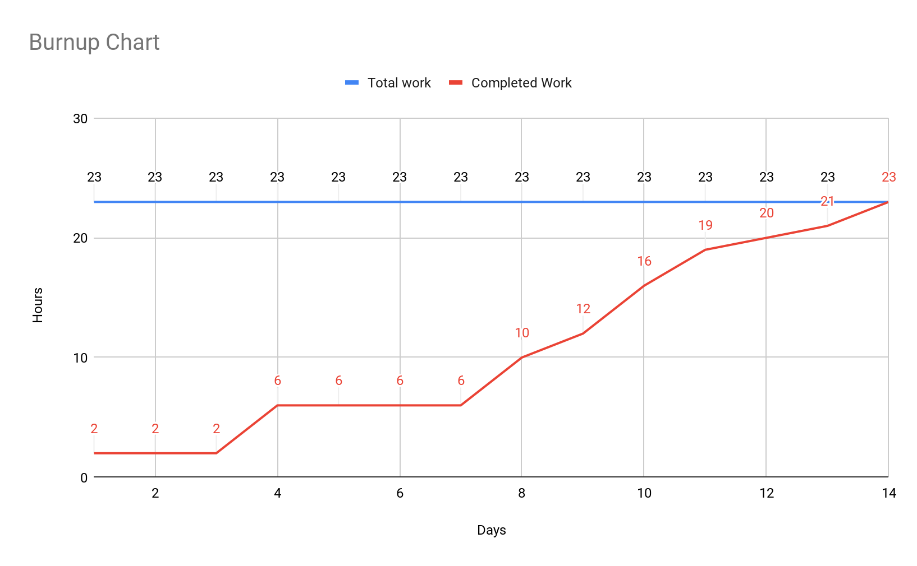

**Prioritize user stories:**

1. Log in/register
2. save_state
3. Interfaces
4. MyCA page
5. compile_error

**Scrum Board:**

<https://jamboard.google.com/d/1WuecReEvjC3s1jhugJyICtRss0PQq9s4udIiGU8Cr9I/edit?usp=sharing>

**Scrum meeting times:**

Mon: 3:00

Wed: 4:00

Fri: 3:00